|  |
| --- |
| Non-survey guidelines  for plans lodged under Sections 22, 32 and 35 of the *Subdivision Act 1988* |

Note: the following information will not apply to plans signed from 1 July 2016 – please see *Survey documents required when lodging a plan of subdivision or consolidation*. The non-survey guidelines will be removed from the website on 1 July 2016.

Land Victoria **may** accept a plan of subdivision without the production of an abstract of field records, if Non-survey guidelines are satisfied and the respective conditions of each section are met.

Before testing against these guidelines, Land Victoria encourages surveyors to consider the ‘downstream’ effects each Non-survey may have. A plan supported by survey improves the product being delivered to Land Victoria, the cadastre and the general community.

All Non-survey plans are to be accompanied by a surveyor’s report, setting out the details of how the plan meets Non-survey guidelines.

If pegs are placed in the process of preparing a Non-survey subdivision, surveyors are required to supply the Surveyor-General with a record of having re-established a parcel in accordance with the provisions of Regulation 16 of the Surveying (Cadastral Surveys) Regulations 2005.

General

The following guidelines are used by Land Victoria when deciding whether a plan of subdivision will be accepted on a Non-survey basis. A number of examples are shown to illustrate the guidelines.

Even if a proposed subdivision falls within the category acceptable to Land Victoria, a licensed surveyor should not prepare a Non-survey plan if they are aware of circumstances which would make it inadvisable to proceed without survey. Examples of such circumstances include:

* problems identified in other surveys;
* fencing out of position with respect to boundaries or connection;
* obvious difficulty in the location of boundaries without the placement of survey marks;
* variations from title position of boundaries abutting streams.

If Land Victoria becomes aware of such problems, Non-survey plans of subdivision will not be accepted, even if the proposal falls within the normal guidelines.

It is not necessary to obtain prior consent to the preparation of a plan of subdivision in a Non-survey form. However, if a licensed surveyor is in doubt as to whether a particular proposal will be accepted without survey, a written enquiry may be directed to the Subdivision Branch at Land Victoria (Level 23, 570 Bourke Street, Melbourne or Subdivision.Branch@delwp.vic.gov.au) for consent to proceed on a Non-survey basis. All relevant information, including the Folio of the Register number and a dimensioned sketch, are to be supplied.

Guidelines

1. Subdivisions are restricted to two lots. An exception may be when a simple splay corner (see 11 below) is created in addition to the two lots.
2. Re-subdivision of a lot on a Non-survey plan is not usually acceptable. Exceptions may apply, e.g. where small ‘remote’ lots are created, as in the example below.

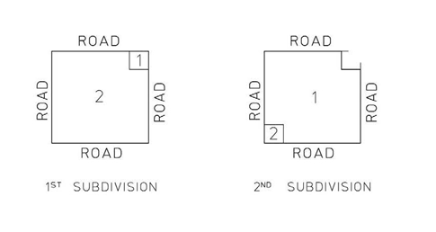

1. The length of any new boundary should not normally exceed 800 metres.
2. New boundaries should be at right angles or parallel to an existing title boundary, as in the following examples.

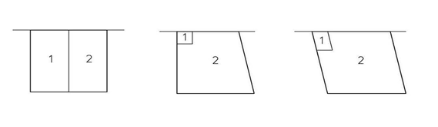

1. No more than two new boundaries are to be introduced.

Exception may be made where new boundaries accord with previously marked lines (boundary, easement, etc.). Where necessary a copy of the relevant survey information showing evidence of marking should be lodged.

Example of exception:

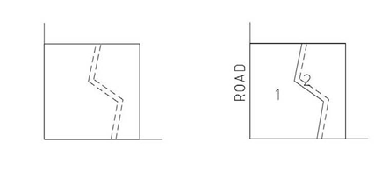

1. The creation of a new lot with ‘dual’ connection is not acceptable.

Example – **NOT** acceptable:

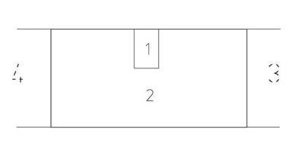

1. Joining corners marked in an earlier survey is acceptable, as in the example below.

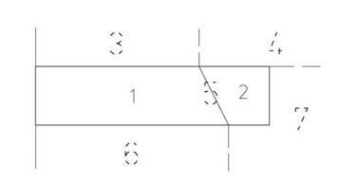

1. A new boundary meeting a curved title boundary is acceptable provided the ‘ordinate’ does not exceed 0.20 metres.

Example:

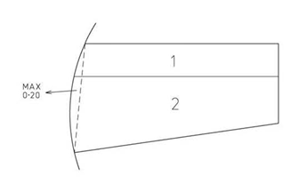

1. A new boundary meeting an irregular boundary is not acceptable.

Example – **NOT** acceptable.

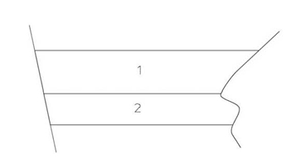

**NOTE: Where the irregular boundary is not subject to movement, a Non-survey subdivision may be acceptable if satisfactory information in relation to the location of the boundary is available and adequately discussed in the surveyor’s report.**

1. The introduction of a party wall easement along a new boundary (whether or not a wall exists) is not acceptable in a Non-survey subdivision.
2. The creation of a new road is usually not acceptable. Exceptions may be made where simple splay corners are created by maintaining an equal distance along the existing alignments.
3. Any subdivision of a Folio of the Register with a ‘warning as to dimensions’ must be based on survey.

Non-survey guidelines for plans lodged under Section 32 of the *Subdivision Act 1988*

An ‘addendum’ abstract of field records and licensed surveyor’s report will normally be required to support Section 32 plans, especially where a new survey was required to compute or mark new boundaries at ground level.

However, plans may be accepted without an abstract of field records if the:

1. original survey was carried out by the same surveyor or survey company within the last five years, and no additional land has been included in the plan, or
2. new boundaries comply with the current Non-survey guidelines for plans of subdivision lodged under Section 22 of the Subdivision Act 1988, or
3. new boundaries can be derived from existing information on the plan or abstract of field records without the need for further survey, or
4. new boundaries are defined by, attached to, or contained within original buildings, and are not required to be marked at ground level.

In cases where it is doubtful if a plan will be accepted without an abstract of field records, surveyors should contact Land Victoria for advice. It is possible that an ‘addendum’ surveyor’s report could be supplied, which on its own may adequately satisfy the requirements of Land Victoria.

Where an ‘addendum’ abstract of field records and licensed surveyor’s report are supplied, they should:

1. satisfy the Surveying (Cadastral Surveys) Regulations 2005.
2. re-establish the datum of the original survey. Partial surveys may be accepted.
3. retain the bearing datum of the original plan/folio if that datum is not MGA94, i.e. the original plan/folio was not based on a survey that included a connection to marks with MGA94 coordinates.

If a connection to MGA94 is observed in the new survey, an appropriate notation should be shown on the addendum abstract of field records describing the relationship to MGA94 datum.

Contact us

For [location and contact details](http://www.dtpli.vic.gov.au/property-and-land-titles/contact-us), refer to [www.delwp.vic.gov.au/property](http://www.dtpli.vic.gov.au/property)>Contact us.

|  |  |
| --- | --- |
| © The State of Victoria Department of Environment, Land, Water and  Planning 2016  byThis work is licensed under a [Creative Commons Attribution 4.0 International licence](http://creativecommons.org/licenses/by/4.0/). You are free to re-use the work under that licence, on the condition that you credit the State of Victoria as author. The licence does not apply to any images, photographs or branding, including the Victorian Coat of Arms, the Victorian Government logo and the Department of Environment, Land, Water and Planning (DELWP) logo. To view a copy of this licence, visit <http://creativecommons.org/licenses/by/4.0/>  **Disclaimer** This publication may be of assistance to you but the State of Victoria and its employees do not guarantee that the publication is without flaw of any kind or is wholly appropriate for your particular purposes and therefore disclaims all liability for any error, loss or other consequence which may arise from you relying on any information in this publication. | **Accessibility**  If you would like to receive this publication in an alternative format, please telephone DELWP Customer Service Centre on 136 186 or email [customer.service@delwp.vic.gov.au](mailto:customer.service@delwp.vic.gov.au). Alternatively, telephone the National Relay Service on 133 677 ([www.relayservice.com.au)](http://www.relayservice.com.au). This document is also available on the internet at [www.delwp.vic.gov.au](http://www.delwp.vic.gov.au). |