Checklist for lodging an application for authorisation

DOCUMENTS REQUIRED | ELECTRONIC FORMAT REQUIRED | NAMING CONVENTION | HELPFUL HINTS
Explanatory Report | Word | [Planning scheme] C[number][Planning Scheme Suffix] Explanatory Report [amendment stage]  Example:  Gumnut C1gumn Explanatory Report Authorisation | Refer to Practice Note 46: Strategic Assessment Guidelines for Planning Scheme Amendments to  assist you in completing the Explanatory Report. | ◻
Amendment map sheets | PDF | [Planning scheme] space C[number][Planning Scheme Suffix] space [map sheet number] (located at the bottom right-hand corner of maps prepared by the department Mapping service) d- (if a deletion map) [type of map]Map(s) [planning scheme map(s) number affected] (if more than one map insert _ between the map numbers affected) space [amendment stage]  Examples:  Gumnut C1gumn 001znMap1 Authorisation  Gumnut C1gumn 002ddoMap1 Authorisation  Gumnut C1gumn 003d-ddoMaps2_3 Authorisation  Gumnut C1gumn 004d-ddo3Map8 Authorisation Gumnut C1gumn 005ho3Map8 Authorisation  Gumnut C1gumn 006emoMaps5_6_7_8 Authorisation Gumnut C1gumn vpoMap10_Authorisation  Gumnut C1gumn lsio-foMap12 Authorisation | At authorisation stage, maps only need to indicatively show the area being amended. To assist in the preparation of authorisation maps please use VicPlan or council’s GIS mapping services.  Authorisation maps submitted to the Department must be submitted using the correct naming convention. | ◻
Amendment clauses and schedules | ATS  Authoring | Run an interim publish to see how the final clause or schedule will look like.  “Name suffix:” [Authorisation under Consideration]  Tick the “Produce PDF Comparisons” to produce a track change document of the clause and schedule against the current version.  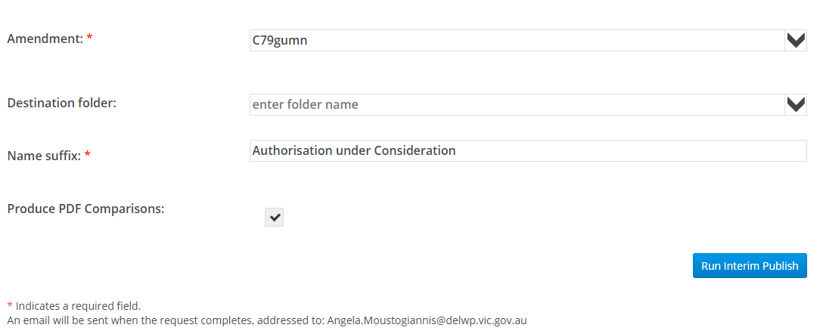 | Final form and track changes of ordinances do not need to be attached when lodging the amendment to the Department.  When running the interim publish, the Department can see, via ATS Authoring, which ordinances where lodged with the amendment.  Contact the Department to obtain advice on the appropriate use of planning provisions and statutory drafting.  Refer to the ‘A Practitioner’s Guide to Victorian Planning Schemes” to assist you in preparing or amending planning scheme ordinances.  Please find attached the link to the ATS guides to assist you in editing in ATS Authoring. | ◻

ADDITIONAL INFORMATION (MAY BE REQUESTED AT AUTHORISATION STAGE)

Draft permit | Word | [Planning scheme] (insert Draft Planning Permit  no.) Draft Planning Permit [amendment stage]. Example:  Gumnut C1gumn PG12345 Draft Planning Permit Authorisation |  | ◻

